**Chapter 4 *Linear Programming***

**Topics:**

• Introduction of a Mixture Problem • Profit Formula

• Review of Needed Algebra • Linear Programming

• Feasible Set • Corner Point Principle

• Resource Constraints • Minimum Constraints

**1. Concepts in a mixture problem**

• Definite **products** can be made by mixing the resources.

• Definite **Resources** are available in known quantities.

• A **recipe** for each product specifies how many units of each resource are needed to make one unit of the product.

• Each product earns a known **profit** per unit assuming that every unit produced can be sold.

• The objective is to find how much of each product to make to maximize the profit with limited resources.

Example 1. One pitcher of lemonade requires 5 lemons, and we have 100 lemons. The profit is $1.50 per pitcher. (a) Identify product(s), resource(s), recipe(s), and profit per unit.

Product:

Resource:

Recipe:

Profit:

(b) What is the maximum number of pitchers that can be made?

(c) Let *x* = the number of pitchers will be made.

Find all possible values of x, which is called feasible set/region.

(d) If 9 pitchers will be made, what is the profit?

(e) If *x* pitchers will be made, what is the profit?

Is it a linear function of *x*?

**2. Mixture Problems**

*A mixture problem is a problem in which a variety of resources avilable in limited quantities can be combined in different ways to make different products.*

Example 2. You bake chocolate chip cookies and chocolate chip muffins and sell them to the public. Assume that you have 60 pounds of flour and 36 pounds of chocolate chips on hand with plenty of the other ingredients.

Recipes:

• Each batch of cookies requires 2 pounds of flour and 1 pound of chocolate chips.

• Each batch of muffins requires 3 pounds of flour and 2 pounds of chocolate chips.

Your profit on each batch of cookies is $8, and on muffins your profit is $13 per batch.

Resources: • Flour. • Chocolate chips.

Limited quantities: • 60 pounds flour • 36 pounds chocolate chips

Different products: • Cookies. • Muffins.

How should you divide your baking between cookies and muffins in order to maximize your profit for the day?

**Variables:**

• *x* = the number of batches of cookies to be made.

• *y* = the number of batches of muffins to be made.

**Profit:** If you make x batches of cookies and y batches of muffins, the profit should be $\$8x+\$13y$

**3. Algebra Needed-Review**

• Sketch the graph of a linear equation of the form a*x* + b*y* = c.

• The graph (the set of all points that make the equation true) will be a line.

• For instance, 10*x* + 20*y* = 800 is a linear equation.

• To sketch the graph of a linear equation, you need to find two points that lie on the line by the following procedures:

– Finding the x-intercept, the point on the line where the line crosses the x-axes with y = 0.

– Finding the y-intercept, the point on the line where the line crosses the y-axes with x = 0.

Example 3. For equation 10*x* + 20*y* = 800, find the intercepts and sketch the graph of the line.

Shade the area where x $≥$ 0, y ≥ 0, and 10*x* + 20*y* ≤ 800

|  |  |  |  |  |  |  |  |  |  |  |  |  |  |  |
| --- | --- | --- | --- | --- | --- | --- | --- | --- | --- | --- | --- | --- | --- | --- |
|  |  | |  | |  | |  | |  | |  | |  | |
|  | |  | |  | |  | |  | |  | |  | |  |  |
| 50 | |  | |  | |  | |  | |  | |  | |  |  |
|  | |  | |  | |  | |  | |  | |  | |  |  |
| 40 | |  | |  | |  | |  | |  | |  | |  |  |
|  | |  | |  | |  | |  | |  | |  | |  |  |
| 30 | |  | |  | |  | |  | |  | |  | |  |  |
|  | |  | |  | |  | |  | |  | |  | |  |  |
| 20 | |  | |  | |  | |  | |  | |  | |  |  |
|  | |  | |  | |  | |  | |  | |  | |  |  |
| 10 | |  | |  | |  | |  | |  | |  | |  |  |
|  | |  | |  | |  | |  | |  | |  | |  |  |
|  | |  | |  | |  | |  | |  | |  | |  |  |
| 0 | | 10 | | 20 | | 30 | | 40 | | 50 | | 60 | |  | 70 |
|  | |  | |  | |  | |  | |  | |  | |  |  |

Example 1 is a **one-product and one-resource** problem.

Example 2 is a **two-product and two-resource problem**.

***A feasible set/region is a set of all possible solutions to a linear programming problem.***

**Definition**: ***A Minimum constraint gives a minimum quantity of a product.***

Example 4. A toy manufacturer has 60 containers of plastic and wants to make and sell skateboards and/or dolls. One skateboard requires 5 containers of plastic and the profit on one skateboard is $1. One doll requires 2 containers of plastic and the profit on one doll is $0.55.

(1) Define *x* and *y*. *x* = the number of skateboards to be made *y* = the number of dolls to be made

(2) The following chart is called a **mixture chart**.

|  |  |  |
| --- | --- | --- |
| Products | Resource  Plastic  60 containers | Profit |
| skatboards  (x units) |  |  |
| Dolls    (y units) |  |  |

(3) Can you make 6 skateboards and 12 dolls? (4) Can you make 10 skateboards and 9 dolls?

(5) Write the resource constraint (plastic).

(6) Write the profit formula.

(7) How much profit can you make if 6 skateboards and 12 dolls will be made?

(8) Write the minimum constraints

(9) The set of all (*x*, *y*) which satisfy the resource and minimum constraints is called the **feasible region**. Graph the feasible region.

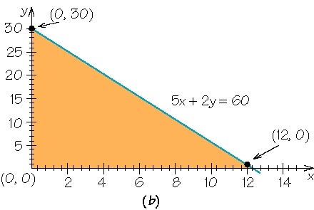

**Definitions:** • **Linear programming** is a set of organized methods of management science used to find optimal solutions while respecting the constraints.

In Example 4, find a pair of (x, y) which maximizes the profit formula: P = $1*x* + $0.55*y*

under the constraints: 5*x* + 2*y* ≤ 60, *x* ≥ 0, *y* ≥ 0

• The term “linear” comes from the facts that resource constraint is a linear inequality and profit formula is a linear function of *x* and *y*.

**Corner Point Principle**: ***In a linear programming problem, the maximum value for the profit formula always corresponds to a corner point of the feasible region.***

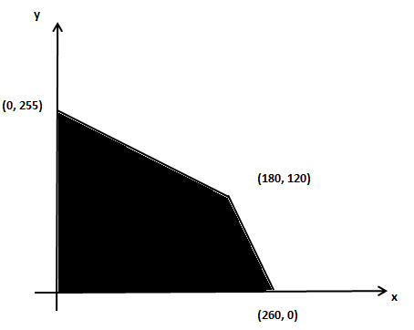

For instance, in the above feasible region, corner points are (0, 0), (0, 255), (180, 120), and (260, 0). The maximum profit must achieve at one of these four points.

Example 4. (Continue) (1) Graph the minimum constraints . Note that *x* ≥ 0 and *y* ≥ 0. (2) Find all corner points. (3) Compute the profit at each corner point.

|  |  |  |  |  |  |  |  |  |
| --- | --- | --- | --- | --- | --- | --- | --- | --- |
| (4) Find the optimal production policy. |  |  |  |  |  |  |  |  |

Example 5. (Continue from Example 4.) If the market has the minimum requirement of at least 4 skateboards and 10 dolls.

(1a) Rewrite the **mixture chart**.

|  |  |  |  |
| --- | --- | --- | --- |
| Products | Resource  Plastic  60 containers | Minimums | Profit |
| skateboards  (x units) |  |  |  |
| Dolls    (y units) |  |  |  |

(1b) Rewrite the minimum constraints

(1c) Redraw the feasible region.

(2) Find all corner points.

(3) Compute the profit at each corner point.

(4) Find the optimal production policy.



Example 6. A clothing manufacturer has 60 yards of cloth and wants to make and sell shirts and vests. Each shirt requires 3 yards of material and provides a profit of $5. Each vest requires 2 yards of material and provides a profit of $3.

The market has the requirement of at least 4 shirts and 6 vests.

(1) Define *x* and *y*.

(2) Make a mixture chart.

|  |  |  |  |
| --- | --- | --- | --- |
| Product | Resources- | Minimums | Profit |
|  |  |  |  |
|  |  |  |  |

(3) Write the resource constraints and minimums as inequalities.

(4) Graph the feasible region.

(5) Find the profit formula. Find all corner points.

(6) Compute the profit at each corner point.

(7) Find the optimal production policy.

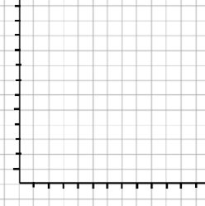

**Terms**:

***• A mixture chart is a table displaying the relevant data in a linear programming mixture problem. The table has a row for each product and a column for each resource.***

***• A resource constraint is an inequality in a mixture problem that reflects the fact of using no more than available resources.***

***• A profit formula is a mathematical expression, involving unknown quantities x and y, tells how much profit results from a particular production policy.***

In example 4,

—two products, skateboards and dolls.

—one resource, plastic containers.

In example 6,

—two products, shirts and vests.

—one resource, cloth.

In example 2, 7

—two products, cookies and muffins.

—two resources, flour and chocolate chips.

Example 7.(Back to Example 2) You have 60 pounds of flour and 36 pounds of chocolate chips.

Each batch of cookies requires 2 pounds of flour and 1 pound of chocolate chips. The profit on each batch of cookies is $8.

Each batch of muffins requires 3 pounds of flour and 2 pounds of chocolate chips. The profit on each batch of muffins is $13.

(1) Define *x* and *y*.

(2) Make a mixture chart.

|  |  |  |  |  |
| --- | --- | --- | --- | --- |
| Product | Resource | Resource | Minimums | Profit |
|  |  |  |  |  |
|  |  |  |  |  |

(3) Write the resource and minimum constraints.

(4) Graph the feasible region.

(5) Find all the corner points.

(6) Find the profit formula. Compute the profit at each corner point.

(7) Find the optimal production policy.



|  |  |  |  |  |  |  |
| --- | --- | --- | --- | --- | --- | --- |
|  |  |  |  |  |  |  |
|  |  |  |  |  |  |  |

Example 8. A toy manufacturer has 60 containers of plastic and 360 person minutes of labor.

One skateboard requires 5 containers of plastic and 15 person-minutes. The profit on one skateboard is $1.05.

One doll requires 2 containers of plastic and 18 person-minutes. The profit on one doll is $0.40.

The manufacturer is required to produce at least 4 skateboards and 6 dolls.

(1) Define *x* and *y*.

(2) Make a mixture chart.

|  |  |  |  |  |
| --- | --- | --- | --- | --- |
|  |  |  |  |  |
|  |  |  |  |  |
|  |  |  |  |  |

(3) Write the resource and minimum constraints.

(4) Graph the feasible region.

(5) Find all the corner points.

(6) Find the profit formula. Compute the profit at each corner point.

(7) Find the optimal production policy.

|  |  |  |  |  |  |  |  |  |  |  |  |  |  |
| --- | --- | --- | --- | --- | --- | --- | --- | --- | --- | --- | --- | --- | --- |
| 5 | | | | | | |  |  |  |  |  |  |  |
|  |  |  |  |  |  |